GREEN COMPUTING https://searchdatacenter.techtarget.com/definition/green-computing

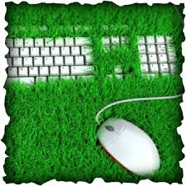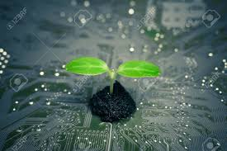

Green computing, also called green technology, is the environmentally responsible use of computers and related resources. Such practices include the implementation of energy-efficient central processing units (CPUs), servers and peripherals as well as reduced resource consumption and proper disposal of electronic waste (e-waste).
One of the earliest initiatives toward green computing in the United States was the voluntary labeling program known as Energy Star. It was conceived by the Environmental Protection Agency (EPA) in 1992 to promote energy efficiency in hardware of all kinds. The Energy Star label became a common sight, especially in notebook computers and displays. Similar programs have been adopted in Europe and Asia.
Government regulation, however well-intentioned, is only part of an overall green computing philosophy. The work habits of computer users and businesses can be modified to minimize adverse impact on the global environment. Here are some steps that can be taken:
- Power-down the CPU and all peripherals during extended periods of inactivity.
- Try to do computer-related tasks during contiguous, intensive blocks of time, leaving hardware off at other times.
- Power-up and power-down energy-intensive peripherals such as laser printers according to need.
- Use liquid-crystal-display (LCD) monitors rather than cathode-ray-tube (CRT) monitors.
- Use notebook computers rather than desktop computers whenever possible.
- Use the power-management features to turn off hard drives and displays after several minutes of inactivity.
- Minimize the use of paper and properly recycle waste paper.
- Dispose of e-waste according to federal, state and local regulations.
- Employ alternative energy sources for computing workstations, servers, networks and data centers.
1. Find a synonym for the underlined words.
Called: named, known as, termed, denominated
Proper: appropiate, adequate, correct
Waste: rubbish, litter
Known as: called, named, termed, denominated
Energy: power
Kinds: types, sorts
Displays: screens, monitor
Overall: general
modified: changed
Minimize: reduce, decrease
Steps: actions, stages, points, measures
Such as: for example, like
Rather than: instead of
2. Complete the text about green computing concepts with the adequate form of the word in brackets.
To promote green computing concepts at all possible levels, the following four approaches are employed:
- Green use: Minimizing the electricity consumption (consume) of computers and their peripheral (periphery) devices and using them in an eco- friendly(friend) manner
- Green disposal: Repurposing existing equipment or appropriately (appropriate) disposing of, or recycling, unwanted electronic (electron) equipment
- Green design: Designing (design) energy-efficient computers, servers, printers, projectors and other digital devices
- Green manufacturing: Minimizing waste during the manufacturing (manufacture) of computers and other subsystems to reduce the environmental (environment) impact of these activities
Government regulatory (regulate) authorities also actively (active) work to promote green computing concepts by introducing several voluntary programs and regulations (regulate) for their enforcement (enforce).
3. Translate into English.
Las tecnologías verdes utilizan de forma más eficiente recursos informáticos y de tecnología de la información, al tiempo que mantienen o mejoran el rendimiento general.
Green technology/computing uses computing and information technology resources more efficiently , while maintaining or improving overall performance Teoria:More efficiently tiene que estar al final de la primera parte de la oracion; no puede estar entre el verbo “uses” y “computing and…”. Es teoria. No puede haber nada entre el verbo y el CD

